DWV Assignment 4
library(readr)

part 1
plot(NA, xlim = c(-20,20), ylim = c(-20,20), xlab="x", ylab = "y", main = "y = 4x + 3", asp = 1)
abline(h = 0,v = 0, col = "black")
grid()
abline(a =3, b = 4, col = "forestgreen", lwd = 2.5, lty = "dashed" )
text(3,17, "y = 4x + 3" , col = "gold", font = 2)
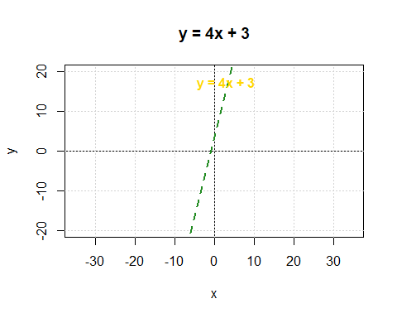

part 2 q1
protected_lands <- read_csv("protected_lands.csv")
New names:
Rows: 13 Columns: 7
── Column specification
──────────────────────────────────────────────────────── Delimiter: "," chr
(2): country, country_code dbl (3): protected_lands, gdp_percap,
tot_gdp_bilions lgl (2): ...6, ...7
ℹ Use `spec()` to retrieve the full column specification for this data. ℹ
Specify the column types or set `show_col_types = FALSE` to quiet this message.
• `` -> `...6`
• `` -> `...7`
mean(protected_lands$protected_lands)
[1] 18.38462
sd(protected_lands$protected_lands)
[1] 10.89754
range(protected_lands$protected_lands)
[1] 4 42
mean(protected_lands$gdp_percap)
[1] 25210.38
sd(protected_lands$gdp_percap)
[1] 19337.7
range(protected_lands$tot_gdp_bilions)
[1] 20 11199
mean(protected_lands$tot_gdp_bilions)
[1] 1125.923
sd(protected_lands$tot_gdp_bilions)
[1] 3056.297
range(protected_lands$tot_gdp_bilions)
[1] 20 11199

p2q2
plot(protected_lands$gdp_percap, protected_lands$protected_lands,
main = "Protected Lands vs. GDP per Capital",
xlab = "GDP per Capita",
ylab = "Protected Lands (% of Total Land Area)",
pch = 19)
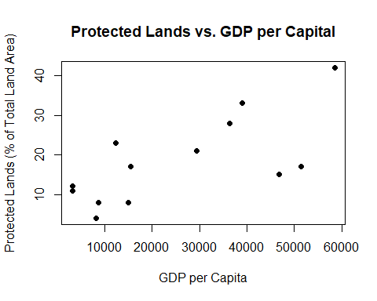

p2q3
plot(protected_lands$tot_gdp_bilions, protected_lands$protected_lands,
main = "Protected Lands vs. Total GDP",
xlab = "GDP per Capita",
ylab = "Protected Lands (% of Total Land Area)",
pch = 19)
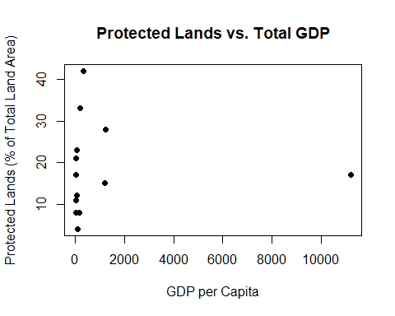

p2q4
model <- lm(protected_lands ~ gdp_percap , data = protected_lands)

p2q5
plot(protected_lands$gdp_percap, protected_lands$protected_lands,
main = "Protected Lands vs. GDP per Capita",
xlab = "GDP per Capita",
ylab = "Protected Lands (% of Total Land Area)",
pch = 19)
abline(model, col = "blue", lwd = 2)
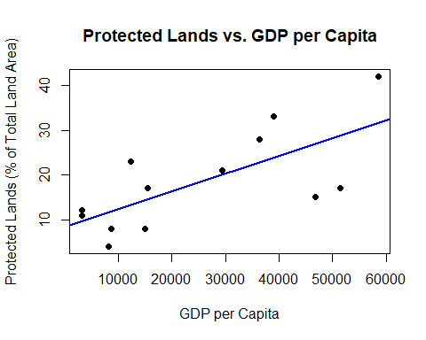

p2q6
model2 <- lm(protected_lands ~ tot_gdp_bilions , data = protected_lands)
plot(protected_lands$tot_gdp_bilions, protected_lands$protected_lands,
main = "Protected Lands vs. Total GDP",
xlab = "Total GDP",
ylab = "Protected Lands (% of Total Land Area)",
pch = 19)
abline(model, col = "blue", lwd = 2)
